QUE-4.3.1-Write a Java program to display the content of a file in HDFS on screen.

ANS-4.3.1-

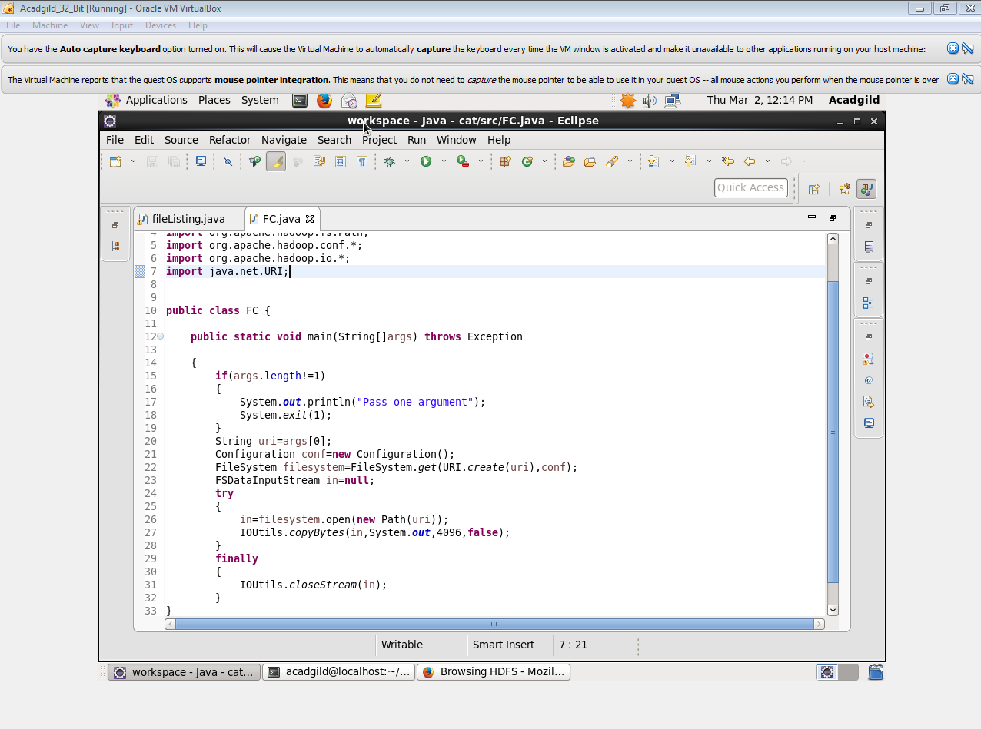

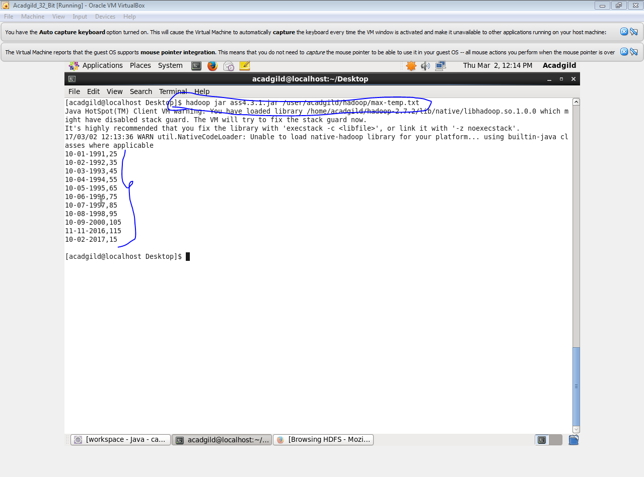

QUE-4.3.2- Write a Java program to copy a file from local filesystem to HDFS.

ANS-4.3.2-

